Chapter 17 Test
1. The Spanish monarchs Ferdinand and Isabella persecuted their religious opponents as one step toward
A. increasing the power of the nobility.
B.
C. helping the Muslims regain power.
D. unifying Spain.

2. In 1588 Spain’s Invincible Armada
A. attacked Muslim pirates in the Mediterranean.
B. was defeated in a battle against the English fleet.
C. subdued a rebellion in the Netherlands.

3. Cardinal Richelieu tried increase the power of the French Monarchy by
A. keeping the Hapsburg family from dominating Europe.
B. strengthening the power of the Holy Roman Empire.
C. organizing a legislature made up of representatives from
each European country.

4. Which of the following was NOT an effect of the Peace of Westphalia?
A. The Hapsburgs focused their plans for expansion on Eastern
and Central Europe.
B. France lost power and influence.
C. The German states became virtually independent.

5. Under Louis XIV, a magnificent royal palace was built at
A. Paris
B. Versailles

6. The reign of France’s Louis XIV was marked by
A. Spanish domination of Europe.
B. the full flowering of absolute monarchy.
C. the limiting of the monarch’s power.

7. Which of the following generalizations in supported by France’s experience under Louis XIV?
A. Religious persecution helps make a nation stronger and
more unified.
B. Religious persecution drains talent from the nation.
C. Religious tolerance leads to a divided nation.

8. One reason for the decline in French prosperity in the late 1600’s was that
A. France had no lawmaking body that could limit the king’s
spending
B. great amounts of money were spent on the French colonies
in America
C. the Estates-General spent too much money on its own
programs

9. By 1750, the great powers of Europe had formed alliances to maintain the ___.
A. balance of power
B. democratic system of government
C. Parliament

10. The principle of habeas corpus in England stated that
A. military law could not be imposed in times of peace.
B. the monarch could not tax without Parliament’s consent.
C. no person could be kept in prison unless charged with a
Specific crime.

11. The English Bill of Rights
A. strengthened individual rights.
B. weakened Parliament.
C. made free speech the right of every English citizen.

12. ___ forced all of Europe to accept Prussia as a great power.
A. Frederick the Great
B. Maria Theresa
C. Oliver Cromwell

13. An autocrat is best defined as a
A. ruler with limited power
B. ruler with unlimited power
C. divine-right king.
14. Peter the Great strengthened central control of Russian government by
A. banning Western ideas of government
B. breaking down much of the bureaucracy
C. requiring all classes of society to serve the state in some
way
15. The last and greatest of the Tudor monarchs was
A. Henry VIII
B. James I
C. William III
D. Elizabeth I

16. What change did Catherine the Great make during her rule of Russia?
A.
B. She improved the plight of the serfs.
C. She avoided warfare with other nations.
D. She allowed greater freedom to the upper classes.

17. Both Peter the Great and Catherine the Great
A..
B. toured Western Europe in disguise.
C. ruled during the 1600’s.
D. wanted better seaports for Russia.

18. Which of the following leader(s) was NOT an absolute ruler?
A. Peter the Great
B. William and Mary
C. Philip II

19. The Edict of Nantes
A.
B. reduced waste and dishonesty in the French government.
C. weakened the French monarchy.
D. provided religious toleration for the Huguenots.

20. Why did Peter the Great travel west?
A. To learn other cultures and help Russia adapt to modern
times.
B. To look for land to conquer.
C. To convert people and set up churches.

21. The theory of divine right states that
A. the Pope is the highest authority for Christians
B. the Pope has authority to settle disputes among monarchs
C. the power of monarchs comes from God

22. “Religious persecution is bad policy in the long run, because it robs a nation of talented citizens.” This hypothesis is best supported by the reign of
A. Henry IV in France
B. Elizabeth I in England
C. Louis XIV in France

23. Which of the following is NOT a true statement about England’s Elizabeth I.
A. She promoted Protestantism in England.
B. She expanded the English navy.
C. She married Philip II of Spain.

24. The English Parliament moved to weaken the monarchy and strengthen individual liberties through the
A. English Trade Agreements
B. formation of the Commonwealth
C. Restoration of the “Merry Monarch”
D. English Bill of Rights

25. Which of the following best describes an absolute
monarch?
A.
B. A ruler whose power is limited only by a constitution.
C. A ruler who is elected for life.
D. A ruler who has complete authority over the government.

26. What was the result of Louis XIV’s persecution of the Huguenots?
A. They rose against him in war.
B. They left France, causing a blow to the French economy.
C. The entire group was killed off.

27. Which of the following best describes the cause of the
English Civil War?
A.
.
B. The Tudors were unable to remove Oliver Cromwell as
Prime Minister.
C. The Hapsburgs inherited the English throne.
D. The Stuarts were unwilling to consult/compromise with
Parliament about taxes.

28. Under the Commonwealth of Oliver Cromwell, England
had:
A. No army.
B. No parliament.
C. No king

29. The Stuart claims to Autocratic rule were often
challenged by _______.
A. The Tudors.
B. Parliament.
C. The Cavaliers.

30. Peter the Great is known for all of the following EXCEPT:
A.
B. Being a strict, yet brilliant leader.
C. Being taller than six and one half feet tall.
D. Changing Russia to a democracy.

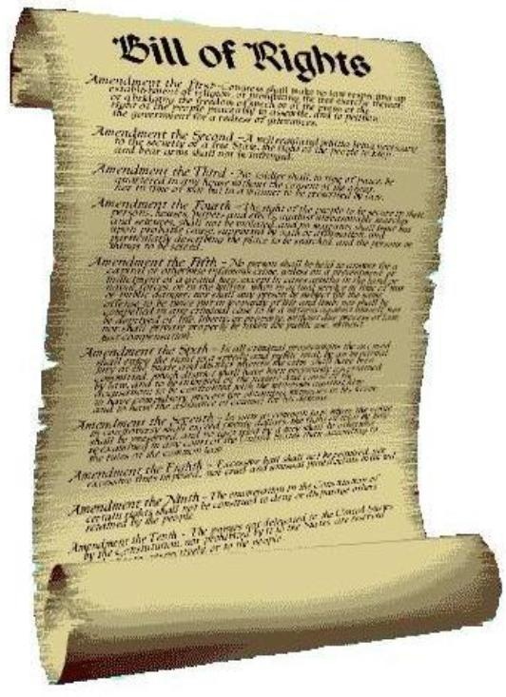
The Palace at Versailles

The royal palace at Versailles, the center of court life during the reign of Louis XIV, is today a symbol of dazzling beauty and opulent living. Millions of gold francs were spent in building and furnishing its lavish chambers, halls, and gardens. So it is difficult to imagine the royal palace as it was in its heyday—cold, crowded, and filthy.
The chimneys in Versailles Palace were so wide that fires were easily extinguished by rain or snow, and wind blew smoke back into the chambers. Heating the enormous rooms was impossible, so ladies who wore fashionably low-cut dresses suffered for style.
Louis XIV enlarged the palace greatly, but because he preferred to have his nobles near him, the vast estate still swarmed with courtiers, sometimes as many as 10,000. He also favored giving the populace the opportunity to observe their sovereign at home. Sightseers were allowed to troop through the staterooms and gaze upon the king as he dined.
The hallways were as private as city streets. They were filled with vendors, tradesmen, and beggars. Cows and goats were brought to the doors of the chambers to be milked. Because there were no bathroom facilities, animal and human filth frequently piled up in the passageways of the palace.
With thousands of courtiers living closely together, with halls crowded with vendors and gawking townspeople, with courtyards filled with animals, and with filth everywhere, it is hard to imagine this royal palace as a fitting place for lavish and elegant living.

Main Idea
31. The main idea of the passage:
A. At its height, the magnificent palace of Versailles was
actually an unpleasant place to live.
B. Versailles was very unsanitary due to overcrowding with
people and animals.
C. Life in palaces of the past was less glorious than most
people think.

Subject Matter
32. The passage focuses on the
A. reign of Louis XIV.
B. construction of Versailles.
C. discomforts of Versailles.
D. beauty of Versailles.

Supporting Details
33. According to the passage, Louis XIV believed in:
A. maintaining large gardens.
B. keeping the palace cold.
C. the need for a quiet retreat.
D. allowing people to view their king.

Conclusion
34. At Versailles, during the reign of Louis XIV, you would not have expected to find:
A. fine paintings and statues.
B. comfortable living quarters.
C. government officials and nobles.
D. peasants and vendors.

Clarifying Devices
35. In developing the main idea, the writer relies mostly on:
A. quotations.
B. non-descript language
C. emotion.
D. description.

Vocabulary in Context
36. As used in the passage, opulent means:
A. rich.
B. middle-class.
C. isolated.
D. comfortable.

37. The ruler who inherited the Netherlands in 1506 and was declared King of Spain in 1515 was
A. Ferdinand I
B. Charles V
C. Philip II
D. William the Silent

38. Which of the following names is NOT associated with
Spain’s Golden Age?
A. Miguel de Cervantes
B. El Greco
C. Isabella of Castile

39. Maria Theresa of Austria was forced to appeal to ___ for military aid when Frederick II invaded Silesia.
A.
B. France
C. Prussia
D.
E. Hungary

40. Which of the following did NOT take place during the reign of England’s Elizabeth I?
A. There was a general decline in the quality of English art and
literature.
B. England’s overseas trade increased.
C. The English navy was expanded.

41. Which three countries took Polish territory during the partitions of the late 1700’s?
A. Russia, England, France
B. Prussia, England, Russia
C. Spain, Austria, Russia
D. Austria, Russia, Prussia

42. In England, people could not be forced to provide shelter and food for soldiers, according to
A.
B. the theory of divine right
C. the Peace of Utrecht
D. the Petition of Right

43. Which King had noble feel it was an honor to clothe, bathe and watch sleep?
A. Louis XIV
B. Miguel de Cervantes
C. Phillip II
D. Henry IV

44. Which king ruled France for 72 years?
A.
B. Louis XIII
C.
D. Henry IV
E. Louis XIV

45. The Tudor monarch who came to the throne in 1558 and was considered one of the greatest rulers in European history was
A. William III
B. Henry VIII
C. Elizabeth I

46. Define “L’etat, c’est moi.”
A. “I have divine right.”
B. “I am the state.”
C. “I am God chosen.”

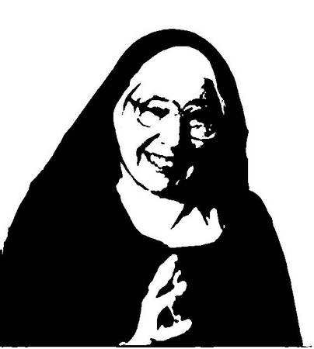

For questions 47-50 use the time line after question 50.

47. Which of the following events happened first?
A. Louis XIV became king of France.
B. Frederick II became king of Prussia.
C. Oliver Cromwell became head of England.
D. Peter the Great became ruler of Russia.

48. Which of the following people ruled during the same time as Louis XIV?
A. Henry IV
B. Peter the Great
C. Frederick II
D. Catherine the Great

49. Which of the following events happened last?
A. Catherine the Great became ruler of Russia.
B. Oliver Cromwell became head of the English
Commonwealth.
C. Peter the Great became ruler of Russia.
D. Louis XIV became king of France.

50. Oliver Cromwell became head of England during the same time that
A. Louis XIV ruled France.
B. Philip II ruled Spain.
C. Frederick II ruled Prussia.
D. Catherine the Great ruled Russia.

