Roman Art & Architecture

Architecture
- Grand, immense palaces, temples and _______________________.
- Improved on the column and the arch.
- Used concrete.
- Rounded dome

The famous Roman hippodrome is called:__________________________________________________

Art
Based on Greeks and Etruscans.
Sculptors stressed __________________________. Showed more expression than the Greeks.
Frescoes and mosaics were popular forms of art in Roman homes.
Mosaic – picture made from colored pieces of stone or ______________________________.
Frescoes – ________________________________________

Science
Ptolemy
Mathematician, geographer, and astronomer
Wrote 13-volume Almagest – “______________________________” It summarized world’s knowledge of astronomy and geography.
***Ptolemy believed that the Earth stood in the center of the universe while the Sun, Moon and the planets moved about it in circles.***

Galen
His theories dominated Roman medicine.
He studied the workings of the human body by dissecting animals.
His studies were the basis of Western medical knowledge for centuries.

Roman Law
Law based on principle of reason and justice and should protect citizens and their property.
Cicero thought obedience to law was one of the requirements of civilized life.
Law of Nations – All people were Roman
***The idea that law could be based on fair and logical principles and ______________________________________ regardless of their nationality was a major contribution to civilization.***

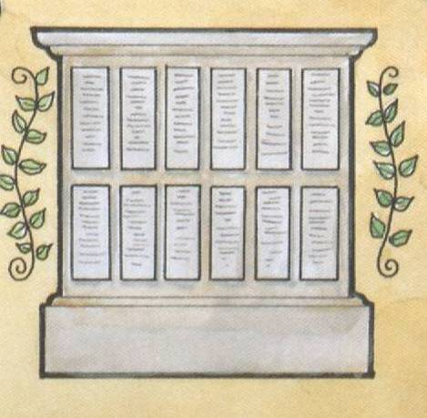
The Twelve Tables: _______________________________________

